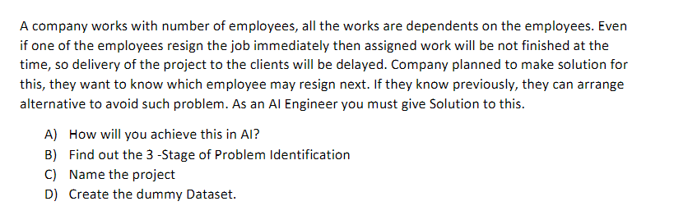

ANSWERS:

1. We want to predict which employee may resign. Based on the output, they want to decide an alternate plan.
2. 3 stages are:

Stage 1 – Domain selection – this is ML

Stage 2 – Learning Selection – this is supervised learning as we have clear inputs, outputs and requirements

Stage 3 – Deciding between regression and classification – this is classification as we will need a yes or no answer as predicted output

1. Project name – AI Based Employee Resignation Prediction
2. Gummy dataset

|  |  |  |  |  |
| --- | --- | --- | --- | --- |
| Input 1 – employee name | Input 2 – age | Input 3 – years of experience | Input 4 – gender | Output – will they resign Y/N |
| Ram | 29 | 3 | M | Y |
| Reena | 30 | 6 | F | N |